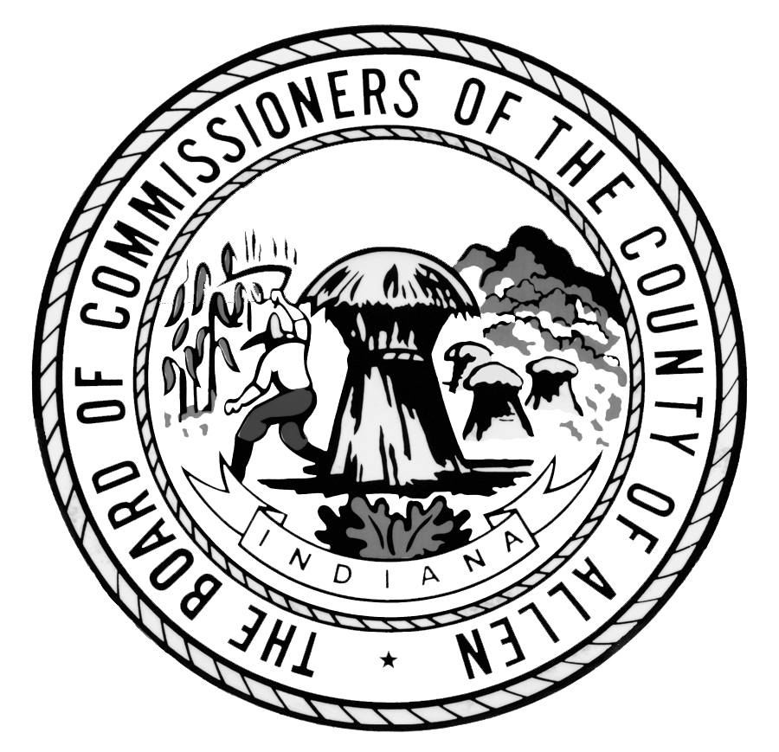Allen County
Job Description

PERSONNEL / POLICY MANAGER

Department: Allen County Community Corrections FLSA Status: Non-Exempt
Under the direction of the CQI/Business Coordinator, the Personnel/Policy Manager manages all personnel and staff administrative duties and is responsible for the review and updating of all Allen County Community Corrections (ACCC) policies. This Personnel/Policy Manager assists in managing a staff of seven (7) individuals and serves as the agency staff compliance officer by ensuring all ACCC policies, procedures, standards of ethical conduct and applicable laws are followed by members of the staff. This position is Not Covered as defined by The Board of Commissioners of the County of Allen Employee Handbook.

ESSENTIAL FUNCTIONS:

- Maintains, composes, updates and implements all Allen County Community Corrections (ACCC) personnel policies and procedures for eight (8) agency divisions.
- Maintains accurate and confidential personnel files for all staff.
- Responsible for the on-boarding process for new personnel and annual professional development program for all personnel, including but not limited to, maintaining records, testing, certifying and anticipating future professional development needs, providing education as needed for a staff of 120+.
- Actively participants in Division feedback sessions and makes suggestions to Executive Management Team on ways to accommodate personnel needs for each Division.
- Initiates performance evaluations on senior staff and monitors the quality and regularity of evaluations on line staff by supervisors.
- Oversees the preparation of necessary paperwork and documentation for new job postings and forwards information to Allen County Human Resources.
- Maintains employee job descriptions and ensures the assigned job duties are accurate for each Division.
- Maintains current job descriptions, pay grids, pay steps, salary splits, appropriation balances, personnel files, disciplinary files and medical files for all staff.
- Oversees bi-weekly payroll online and maintains electronic and hard copy files of payroll amounts, benefit deductions and other deductions for all staff.
- Conducts personnel compliance audits and provides supervision results to ensure work performed fulfills policies, procedures, processes and standards.
- Maintains, composes, updates and implements all policies and procedures for day-to-day operations of each Division, including procedural and training manuals.
- Prepares reports for the Executive Director on issues observed and recommends improvements for divisional and personnel compliance.
- Investigates all staff performance-based issues and prepares paperwork for disciplinary proceedings, presents information to the Executive Director and presents final documentation to employee with action(s).
- Collaborates with the Executive Management Team to institute and maintain a compliance or code of conduct communication and training program.
- Assists the Executive Management Team in the development, initiation, maintenance and revision of policies and procedures.
- Reviews requests for time off, compensation time accrual, overtime accrual or short notice requests for changes in work schedules and provides approval of requests based on the merit and legitimacy of the request.

ESSENTIAL FUNCTIONS (Continued):

- Oversees and acts as a liaison for work injury information, including but not limited to, completing all First Report of Injury (FROI) packets and enduring all information is accurate and complies with OSHs Reporting Regulations and Worker’s Compensation.
- Initiates and maintains FMLA Certification and files ensuring legal compliance.
- Works directly and indirectly with the criminal justice, law enforcement and judicial systems.
- Performs all other duties as assigned, including overtime as required.

REQUIREMENTS:

- Bachelor’s Degree in Business, Public Affairs, Human Resources or related field and at least five years’ experience in a community corrections program
- SHRM Certification preferred
- Strong supervisory skills in order to manage sensitive staff concerns
- Strong computer skills with the ability to use Microsoft Office and other job related software
- Ability to maintain strict confidentiality
- Strong written and verbal communication skills
- Knowledge of the criminal justice, law enforcement and/or judicial system, including the ability to apply law to agency mission
- Ability to be detailed oriented and have the ability to maintain accurate records
- Ability to maintain strict confidentiality of all Division records and staff information
- Understanding of data management and electronic monitoring systems and controls

DIFFICULTY OF WORK:

The Personnel/Policy Manager performs work that is broad in scope and involves significant variables when maintaining and implementing Allen County Community Corrections (ACCC) policies and procedures and strategic plan. Significant judgement is required to determine the need for program alternatives or new program development.

RESPONSIBILITY:

The Personnel/Policy Manager provides major contributions when conducting compliance audits to ensure ACCC goals are being met. General objectives and boundaries are given and work is reviewed for overall accomplishment of ACCC mission and goals.

PERSONAL WORK RELATIONSHIPS:

The Personnel/Policy Manager maintains frequent contact with other County employees including the Executive Management Team regarding strategies, policies and procedures.

WORKING CONDITIONS:

The Personnel/Policy Manager works in a standard office setting with frequent sitting and the ability to move about freely. Some lifting of up to twenty pounds, bending, pushing/pulling loads, reaching over head, kneeling and crawling exists. Frequent mental/visual efforts, typing, monitoring of equipment, detailed inspection and great attention to detail are required.

SUPERVISION:
None

LICENSING:
None

IMMEDIATE SUPERVISOR:
CQI / Business Coordinator

HOURS:
40 hours / week; including overtime as required

Please visit the Allen County website at http://www.allencountyjobs.us/

